* 1. User Interface:

The UI should follow a modern and clean design, making it easy for users to read the article and generate an AI summary of the content.

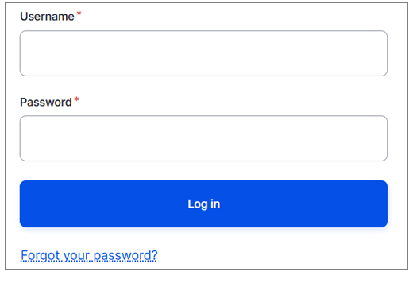

Figure 3: Login Page

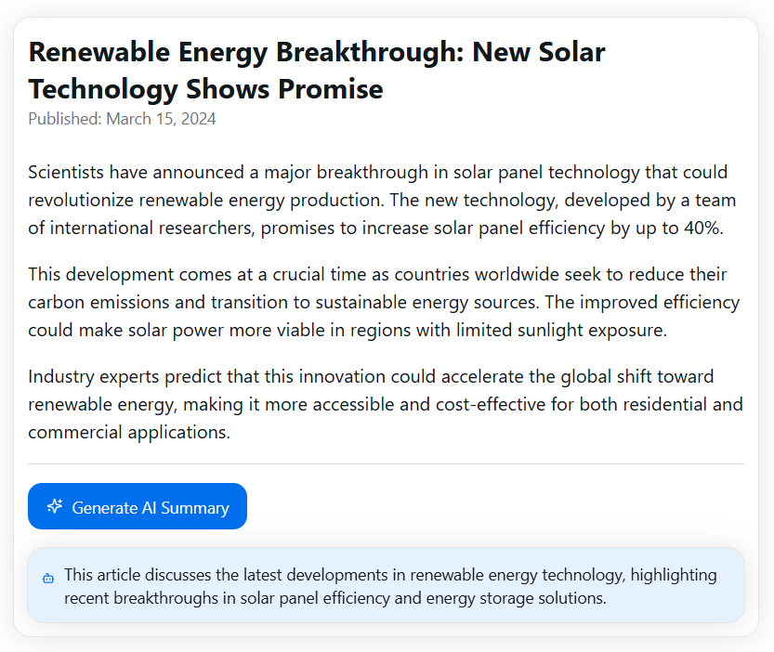

Figure 4: News Article with "Generate AI Summary" Button